**Advanced Web Programming – Week 5**

**BLADE VIEW, WEB TEMPLATING AND DATA TABLES**



**Baskoro Seno Aji**

**2341720063 / 05 / TI-2I**

**Github Link :** [**Github**](https://github.com/Anothaatype/University/tree/main/Semester-4/Pemrograman-Web-Lanjut/Week-3/PWL_POS)

**Polytechnic State of Malang**

**Practicum 1-Admin LTE Layouting**

* **Layouts :**

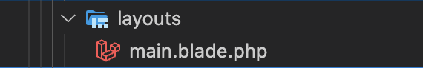

* **Components :**

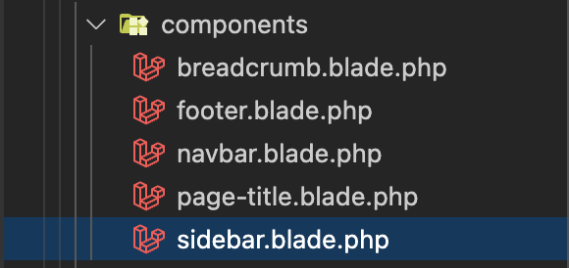

**Practicum 2-Layout Usage**

* **Dashboard :**

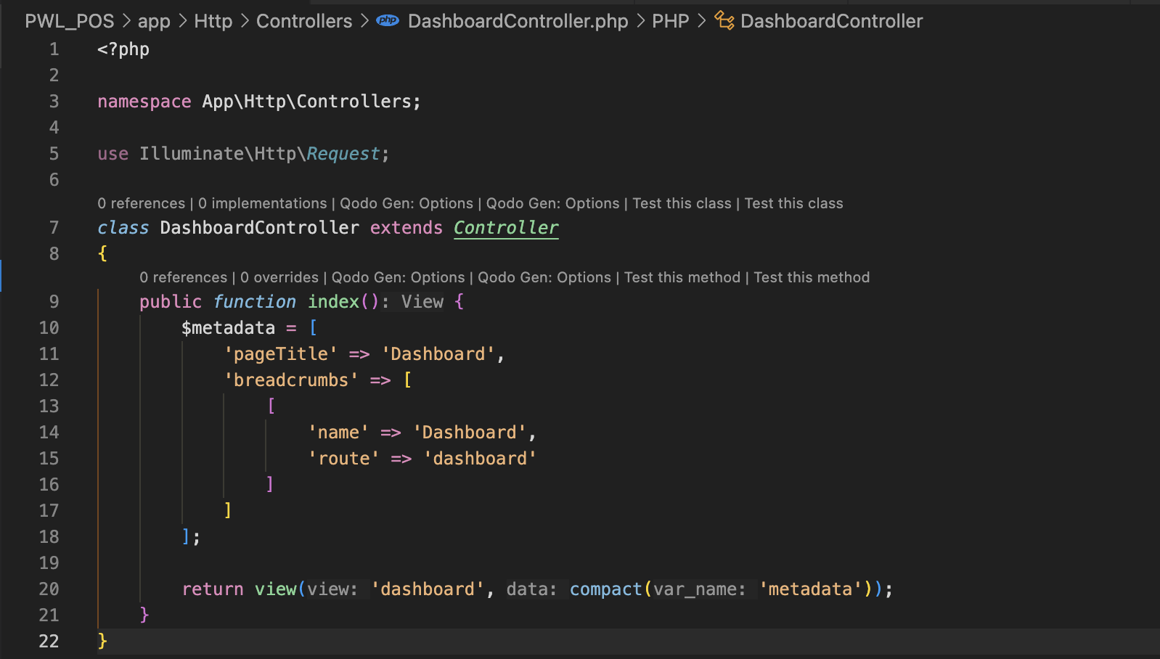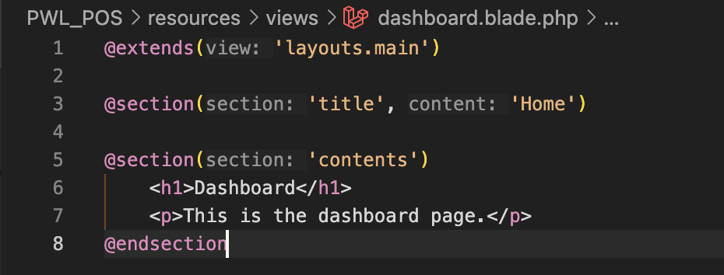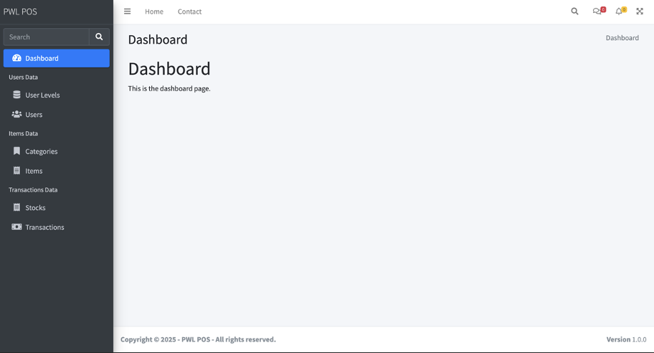

**Practicum 3-JQuery Data Table Implementation**

* 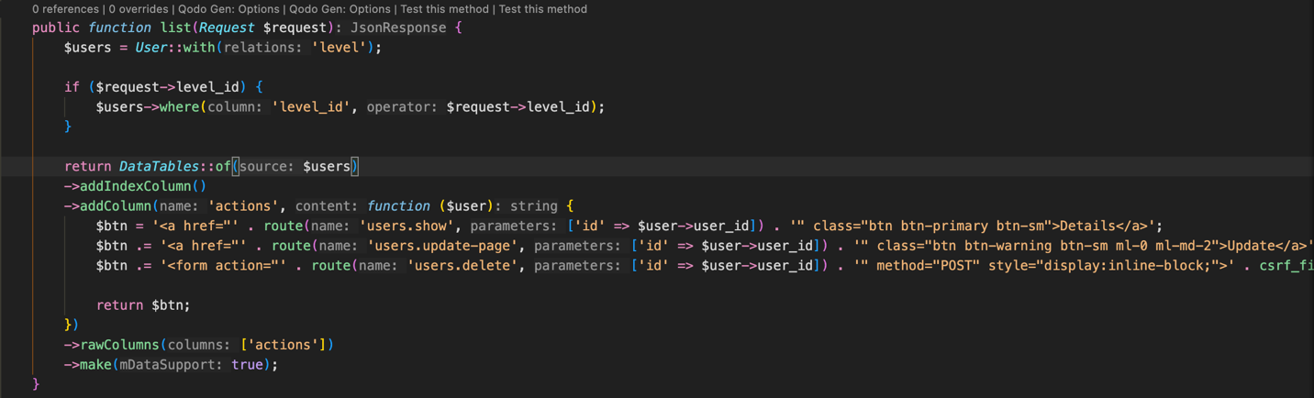**List Data :**

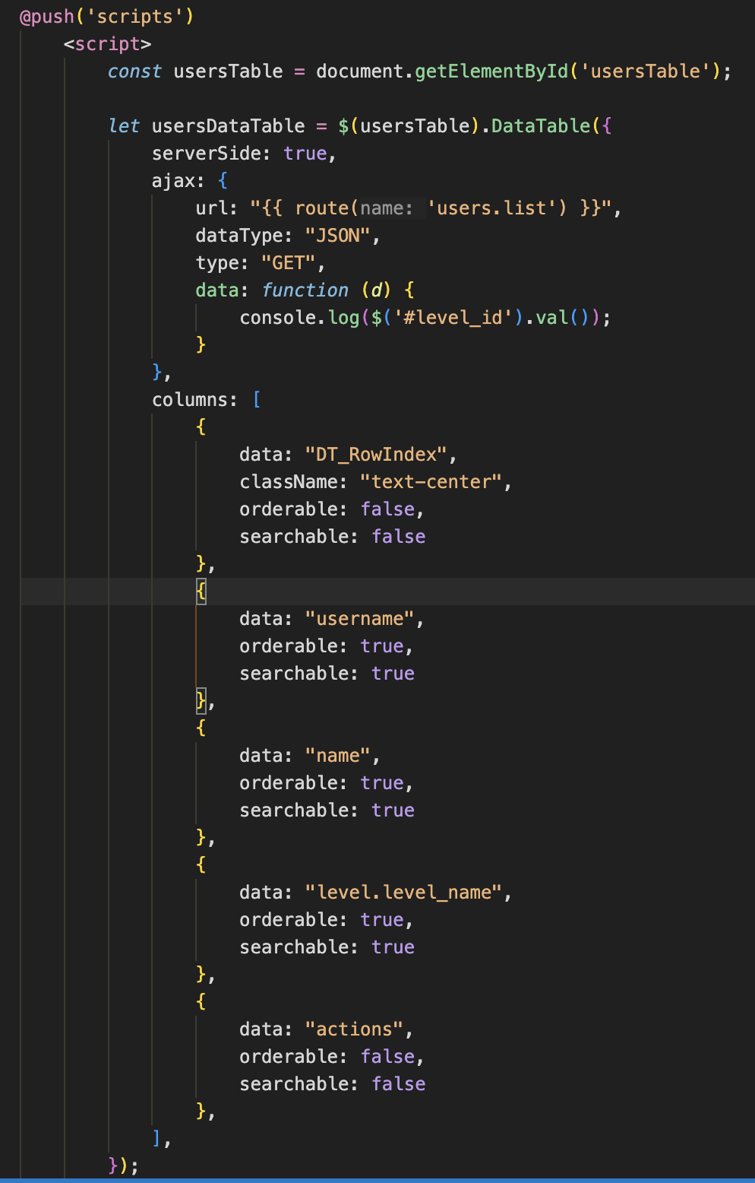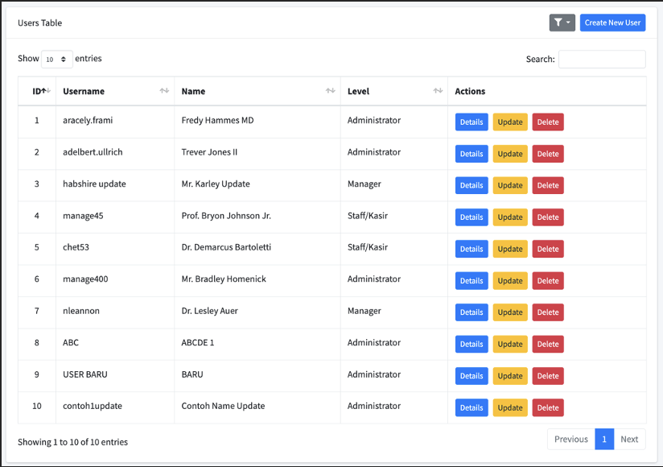

* **Details Data :**

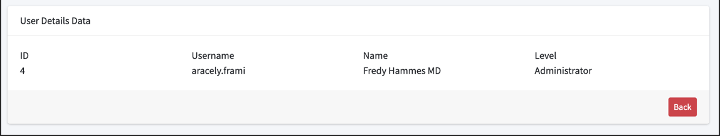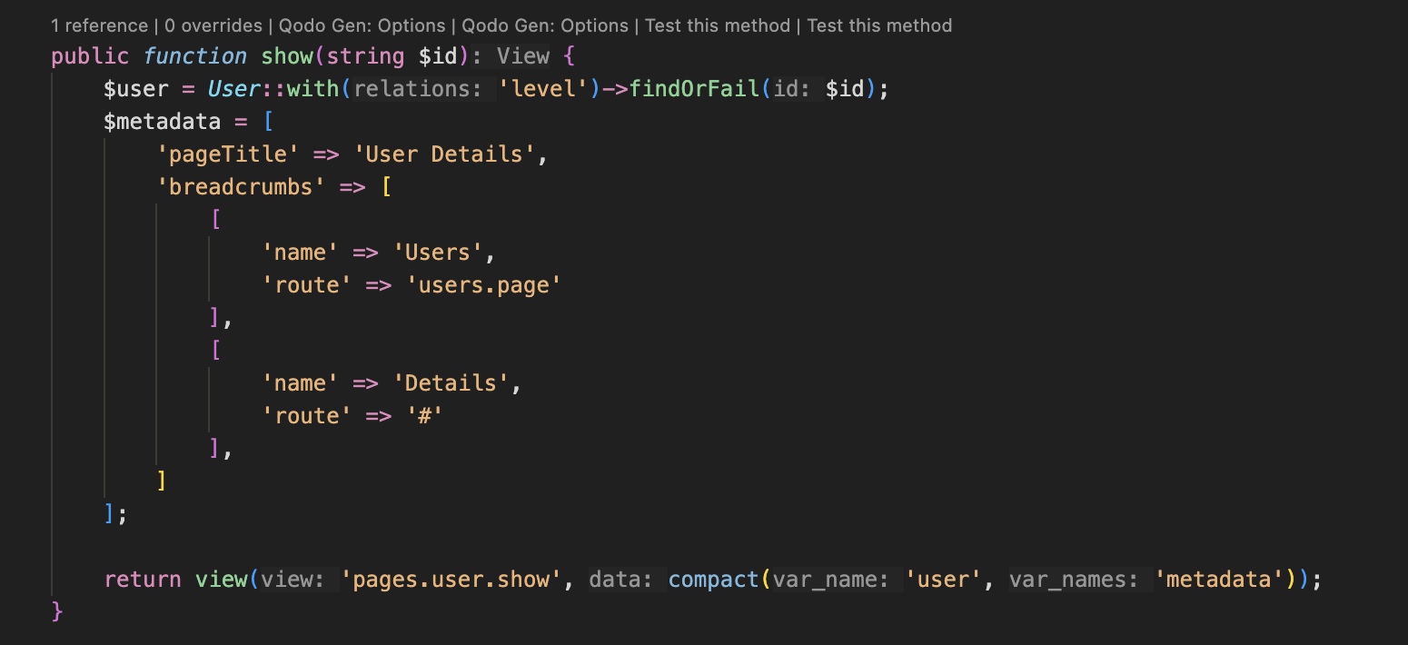

* **Create Data :**

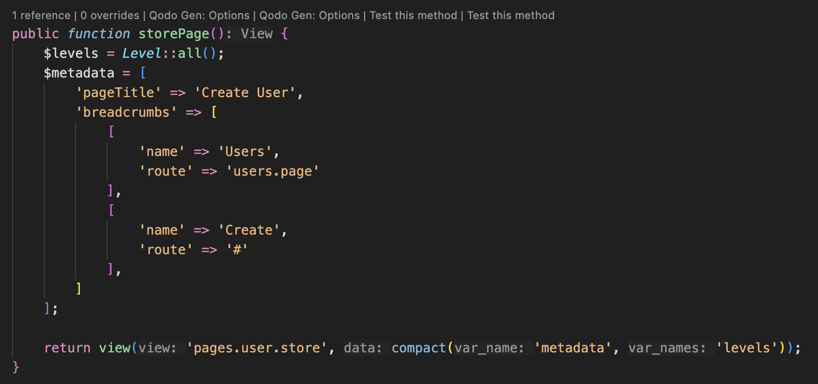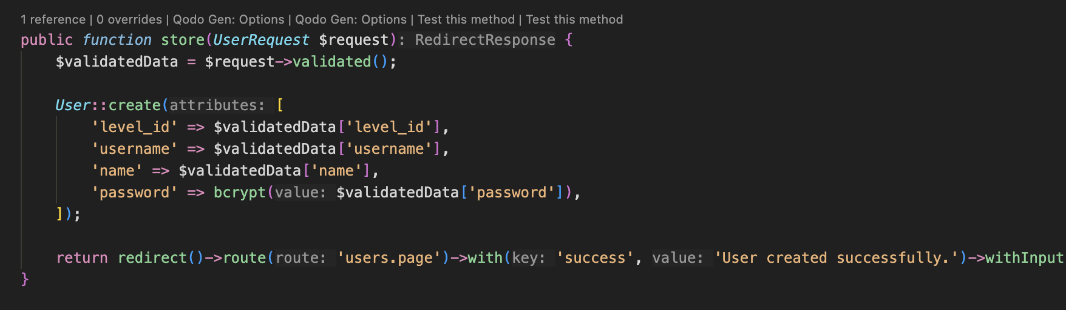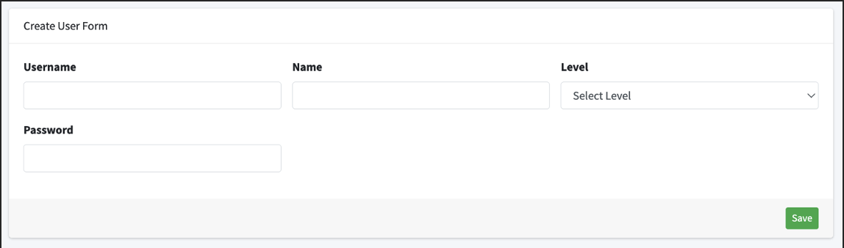

* **Update Data :**

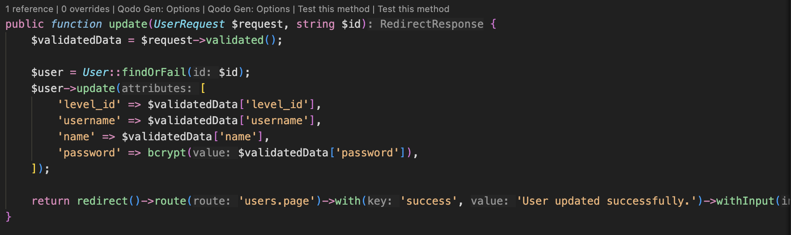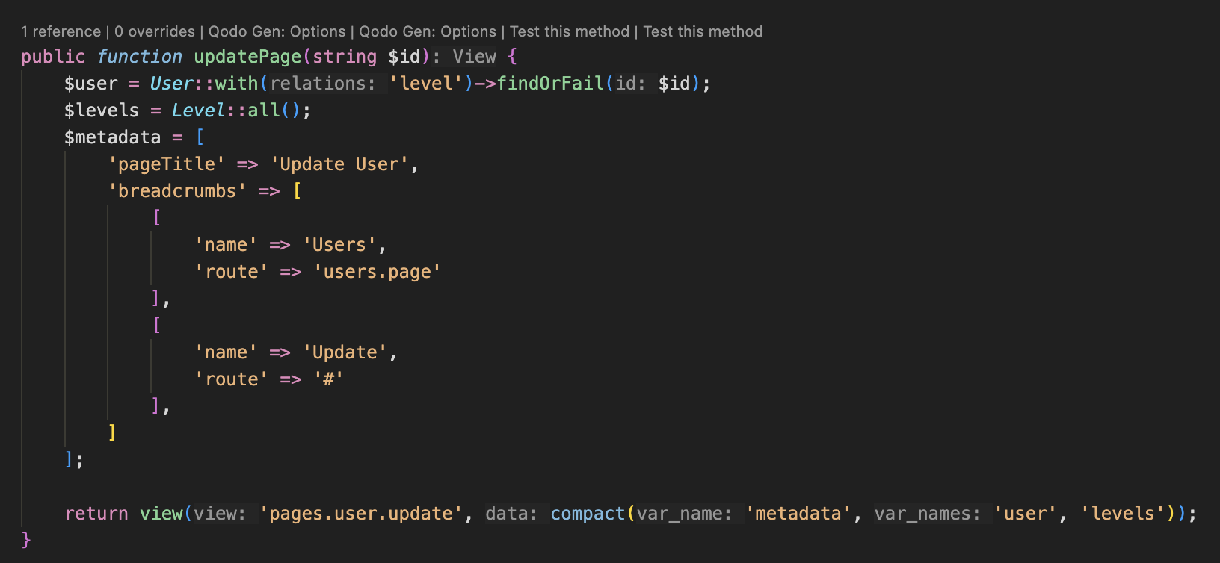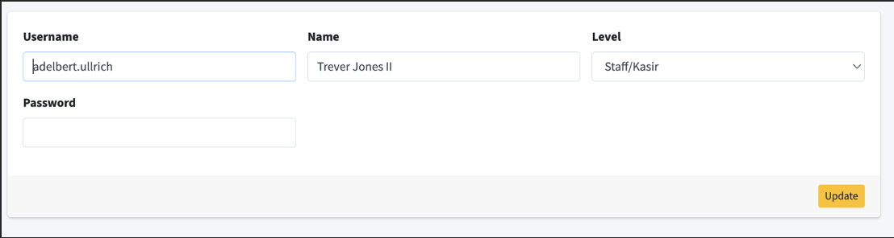

* **Delete Data :**

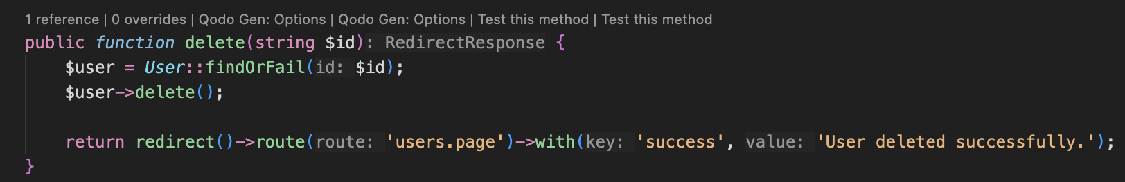

**Practicum 4-JQuery Data Filter**

* **Filtering :**

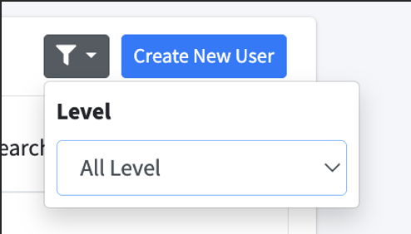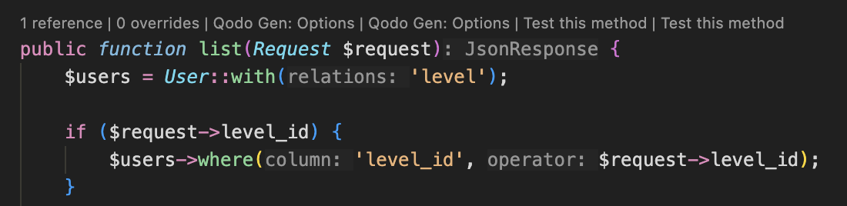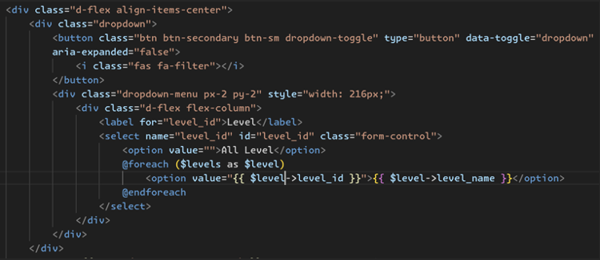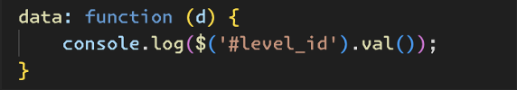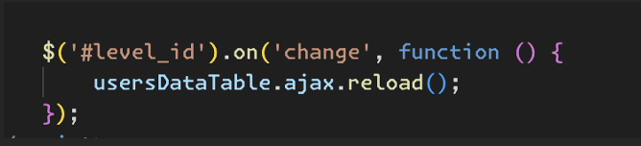

**Assignment**

* **Levels Table :**

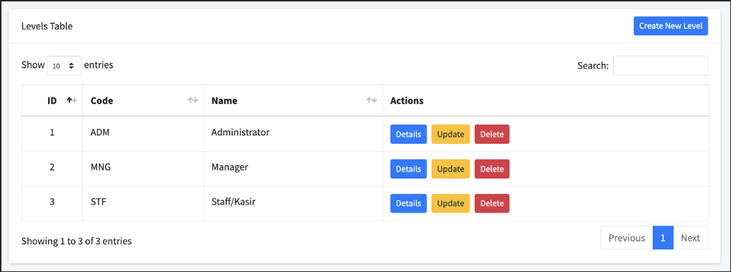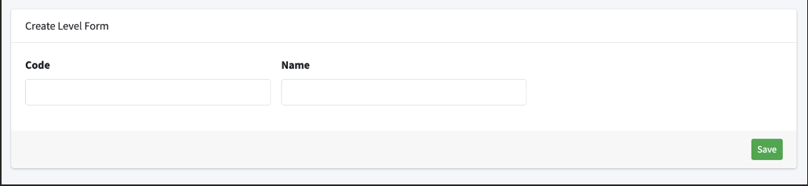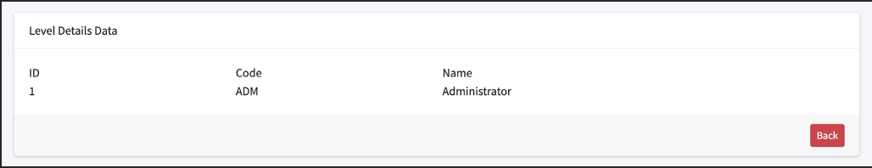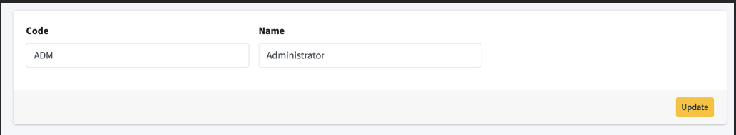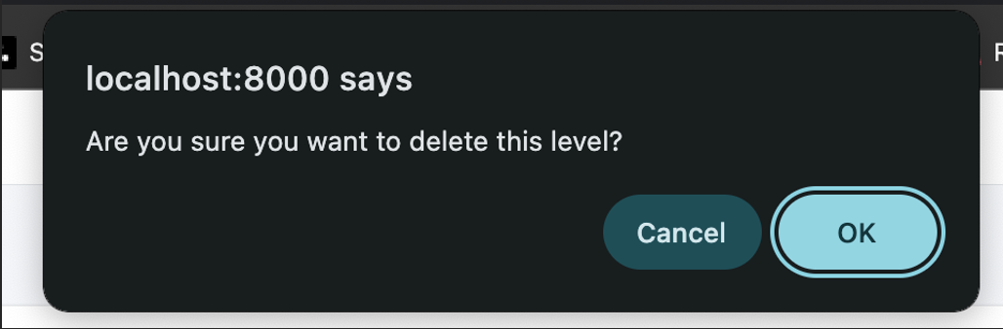

* **Categories Table :**

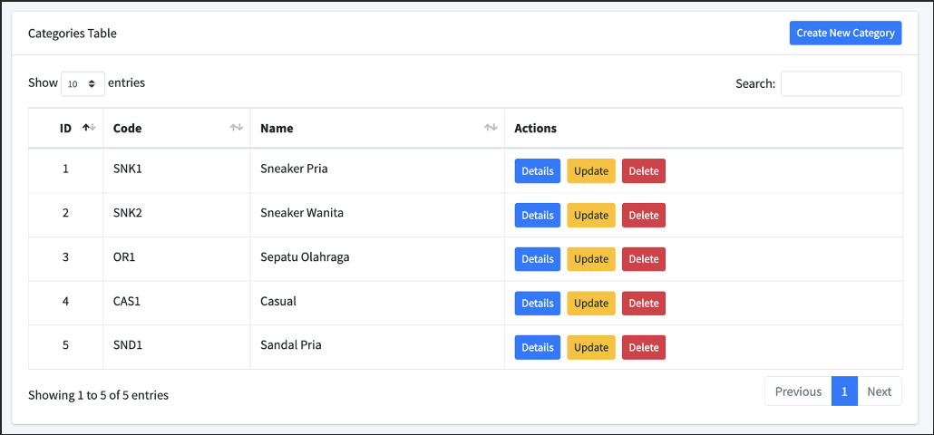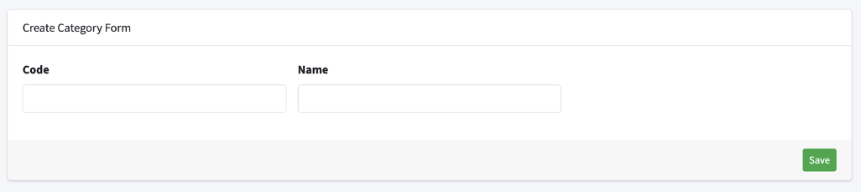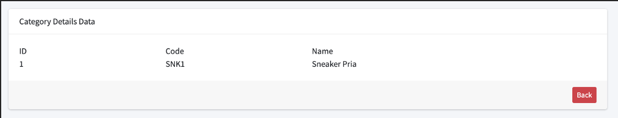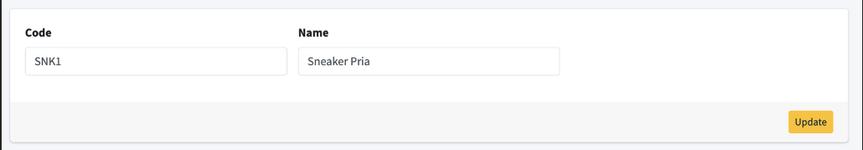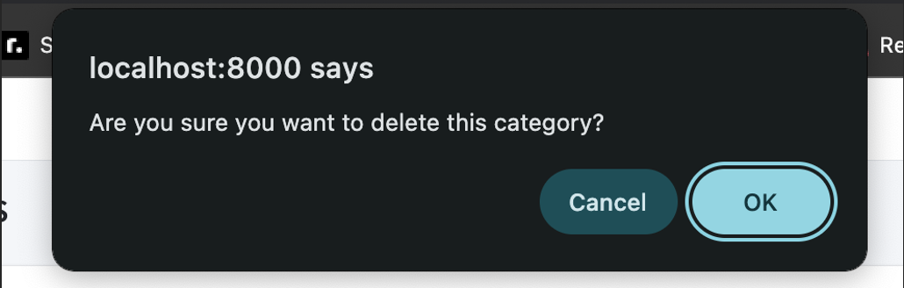

* **Stocks Table :**

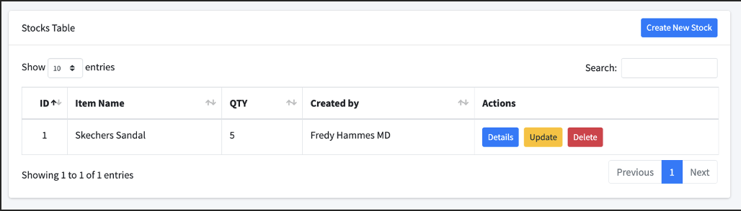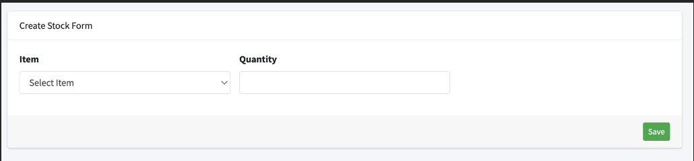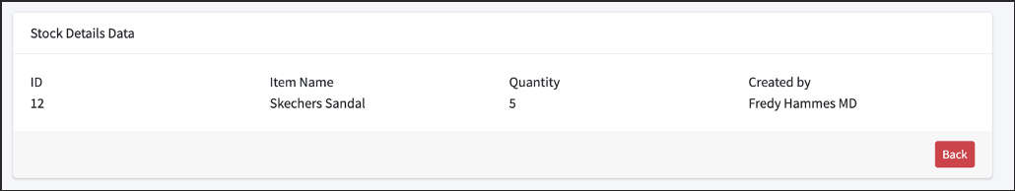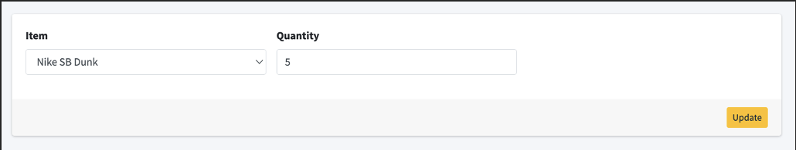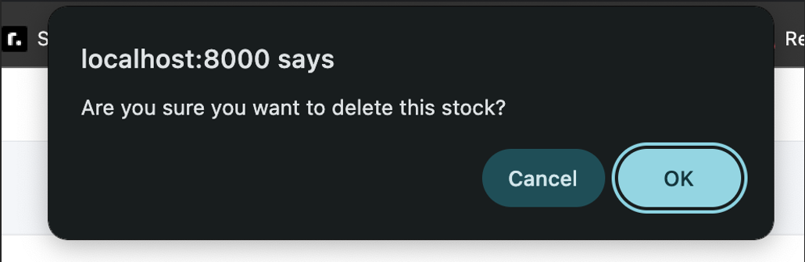

* **Items Table :**

